SPONSORED BY THE: PBCDA STATE TEAM

PALM BEACH COUNTY DARTING ASSOCIATION

1st ANNUAL GOOD FRIENDS GOOD FUN
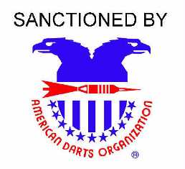
- $1,500
SATURDAY, MARCH 31, 2012

* $1.00 FDA & $2.00 ADO per singles entry Registration cutoff 15 minutes before each match Steel tip darts only
EVENT | LADIES  DOUBLES  CRICKET | MEN’S  DOUBLES  CRICKET | MIXED  DOUBLES  501 | LADIES  SINGLES  501 | MEN’S  SINGLES  501
TIME | 11:00am | 11:30am | 1:00pm | 3:00pm | 3:30pm
ENTRY | $26 | $26 | $26 | $17* | $17*
1ST | $120 | $150 | $150 | $120 | $160
2ND | $70 | $100 | $100 | $70 | $80
3RD – 4TH | $30 | $50 | $50 | $20 | $40
TOTAL | $250 | $350 | $350 | $230 | $320
FDA membership required – Weekend membership available

Location: Major’s Pub
7118 S. Military Tr I-95 to Hypoluxo Rd. West to Military Trail,
Lake Worth South on Military Trail to first left turn
(561) 965-0886 same strip mall as Checkers.
South / east corner…3 miles from I-95
Contact Persons: Becky Jordan
(561) 371-0133
Steve Lambiase
(561) 704-3268

Note: Entry fees are processing fees for Tournament Management,
Administration and advertising. Prize monies are paid by the
Tournament Sponsors and are not part of the processing fees. This
Meets the criteria for the Florida Gaming Laws. Prize monies are
guaranteed by NCDU State Team.

